## Internship Summary Report

The summary report is an important part of the internship program. And it is a subject that the students must complete. The report is completed by the training students themselves.

The report should include professional skills training, corporate culture experience, team spirit training, professional ethics training, professional ethics training, criticism or suggestions on internship, etc. The total number of words should not exceed 2000 words and not less than 800 words.

According to the needs of Suncaper Co., Ltd., your training experience may be extracted and used for company promotion. Of course, with your own consent, please choose whether to agree:

Name：Yuwantha Rashmika Heruppage Student ID： 2018521460130

Major： Software Engineering Mobile：

1. Introduction

Ecommerce, or electronic commerce, refers to transactions conducted via the internet. Every time individuals and companies are buying or selling products and services online, they’re engaging in ecommerce. The term ecommerce also encompasses other activities including online auctions, internet banking, payment gateways, and online ticketing.

1. Main functions and performance

In this E-Commerce Framework, we have the basic functions that every E-Commerce System needs. When a customer uses the unit, he should be able to choose the item or service he wants to purchase. The customer must also choose payment methods. Sellers have the option of adding their items to the product list.

* Components
* Products
* Cart Items
* Cart Service
* Navigation End
* Menu Services
* Payment Method
* Checkout
* Buyer/Seller Accounts [ to manage, add or remove items]

1. Evaluation of the Front End development process

* Main components
* Pages
* App Routing
* Assets

* Main Components

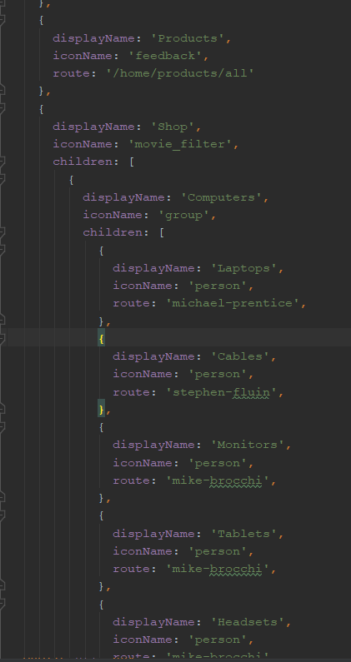

In this development process, this main components.ts includes the products, checkout, cart, Wishlist, about us, contact us etc. These are the things which mainly has to be in an any web site front end. So, accordingly I used the same way that will suits to our e-commerce web store as well.

* Pages

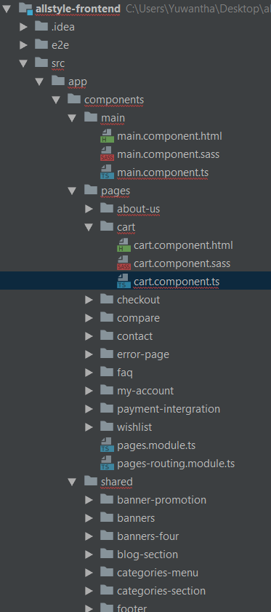

As I mentioned before in the components here I designed the pages which needs to be in the web store likewise. All these are connected to each other as if an user or a guest clicks it reads the data or if they add a product to cart or buy a product from our store it will update our database and it will store the data in our database accordingly to the user id.

* App Routing

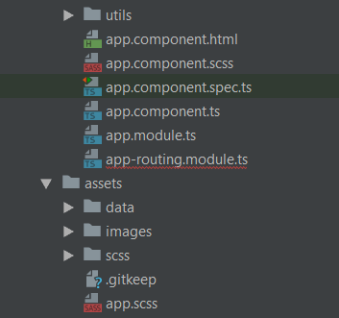

When a user navigates to a page, Angular Router performs the following steps in order: it reads the browser URL the user wants to navigate to. it applies a URL redirect (if one is defined) it figures out which router state corresponds to the URL.

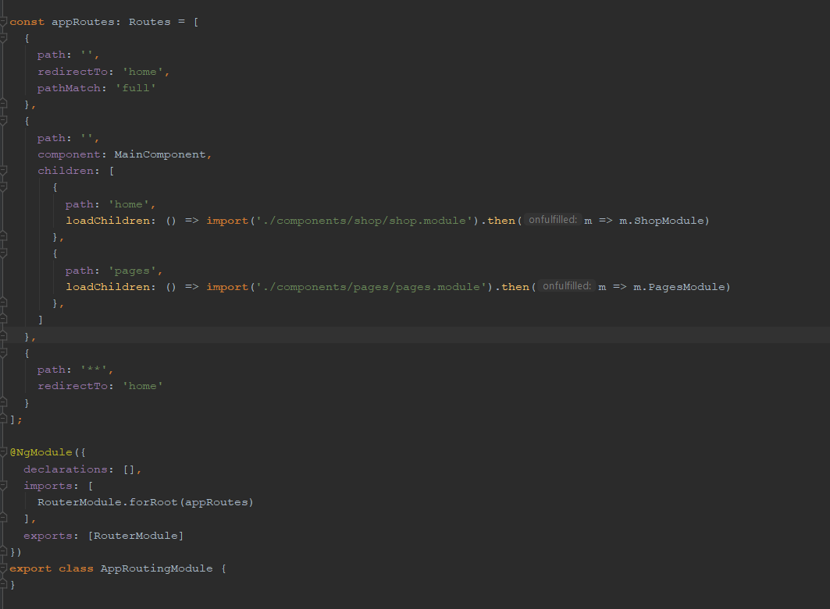

Routing basically means navigating between pages. You have seen many sites with links that direct you to a new page. This can be achieved using routing. Here the pages that we are referring to will be in the form of components. Most developers should always implement a Routing Module for the sake of consistency. It keeps the code clean when configuration becomes complex. It makes testing the feature module easier.

It is an array which holds all the routes we need in our project.The const routes is given to the RouterModule as shown in @NgModule. To display the routing details to the user, we need to add <router-outlet> directive where we want the view to be displayed.

* Assets



The User Interface is developed under this part. When a user comes to our web store the interface, they can see is designed by the assets which are the CSS, JS and images. So these are the main components which beautify a website.